

**Quality Hospital Care**

**for People with Intellectual Disabilities**

**Learning Resource**

**Activity Booklet Group**

**Disability Staff Pathway**

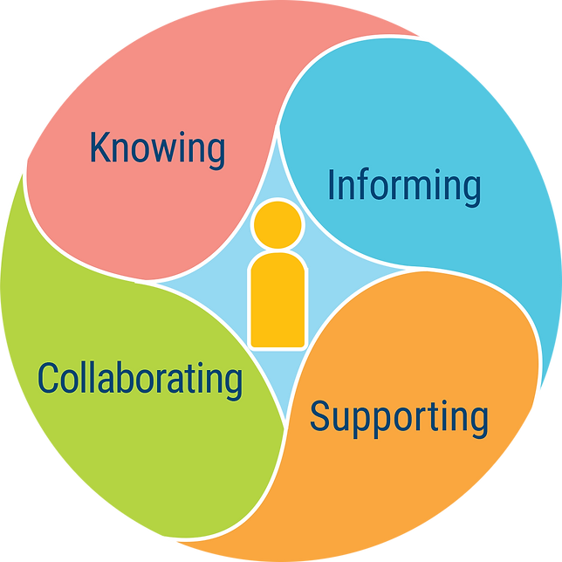

https://www.hospitalinclusion.au



Disability Staff Pathway: Waiting in Emergency

Activity 1:

In groups of 5-6 people, ask one person to describe their most recent positive experience of accompanying a person with intellectual disabilities in an Emergency waiting area. Then, using a board or butcher's paper to record discussion points, apply the Learning Framework to this experience by responding to each of the following:

1. Describe any support, such as adjustments, that met the needs of the person with intellectual disability.

Click or tap here to enter text.

For these supports,

* 1. List what hospital staff needed to know about people with intellectual disabilities, the disability system, and the role of disability support workers?

Click or tap here to enter text.

* 1. List what the disability support worker needed to know about hospitals and their processes?

Click or tap here to enter text.

* 1. Identify specific information about the person with intellectual disability was shared with hospital staff?

Click or tap here to enter text.

* 1. Describe the collaboration across hospital and disability staff.

Click or tap here to enter text.

Activity 2:

In the same groups, ask one person to describe their most recent negative experience of accompanying a person with intellectual disability in an Emergency waiting area. Then, using a board or butcher's paper to record discussion points, apply the Learning Framework to this experience by thinking about what would have made it more positive:

1. Describe any support, such adjustments, that would have met the needs of the person with intellectual disability.

Click or tap here to enter text.

For these supports,

* 1. List what hospital staff need to know about people with intellectual disabilities, the disability system, and the role of disability support workers.

Click or tap here to enter text.

* 1. List what the disability support worker needs to know about hospitals and their processes.

Click or tap here to enter text.

* 1. Identify specific information about the person with intellectual disability that should be shared with hospital staff.

Click or tap here to enter text.

* 1. Describe the collaboration across hospital and disability staff needed for this experience to be more positive.

Click or tap here to enter text.



Disability Staff Pathway: Emergency Department

1. In groups of 4-5 participants, complete as much as you can of an example hospital passport (in your workbook) for either someone with intellectual disability you all know or a fictional person.

Click or tap here to enter text.

1. Highlight the information or sections that you could not provide and who you think would be the best person to ask (such as a parent or sibling).

Click or tap here to enter text.

1. Explain why or why not this information could contribute to information sharing, collaboration and/ or supporting if this person went to hospital.

Click or tap here to enter text.



Disability Staff Pathway: Transitions

***[](https://youtu.be/r4-cMgw6waQ)***

***In groups of 4-5, watch the video*** [***Moving to a Ward***](https://youtu.be/r4-cMgw6waQ) ***(from this section). Discuss and record your answers to questions so that you can share them with other groups.***

List the information Johnno (Cassandra's support worker) shared with Lorraine (the hospital Social Worker).

Click or tap here to enter text.

1. Describe how Johnno and Lorraine collaborated.

Click or tap here to enter text.

1. Explain the support that Cassandra needed to help her in this transition.

Click or tap here to enter text.

1. Describe anything else that could have occurred in this scene in terms of the Framework processes of Knowing, Informing, Collaborating and Supporting.

Click or tap here to enter text.



Disability Staff Pathway: Ward Stays

In groups of 4-5 participants, discuss the following and record your discussion on a whiteboard or butcher's paper for sharing with other groups.

1. Describe any experiences within the group of supporting a person with intellectual disability during a hospital stay.

Click or tap here to enter text.

1. Identify what you needed to know about hospitals that would have helped you.

Click or tap here to enter text.

1. List specific information about the person with intellectual disability that you told or feel you should have told the nursing or other hospital staff.

Click or tap here to enter text.

1. Describe how you felt when interacting with the ward staff.

Click or tap here to enter text.

1. If a family member was involved, describe how you felt when interacting with them.

Click or tap here to enter text.

1. Explain what made it or could have made it a collaborative experience.

Click or tap here to enter text.



Disability Staff Pathway: Discharge

In groups of 4-5 participants, prepare for a role-play of a discharge meeting for a woman, Hanna, aged 52 years, who communicates with speech, but is often very shy in a group and with unfamiliar people. She has spent 5 days in hospital recovering from a fractured right arm (she is right-handed). Before being in hospital, she had lived in a group home with 2 other women. Her house supervisor says Hannah can't return to this home, at least not until she regains full function of her arm and hand, which, according to the rehabilitation team, will require some months. The meeting has been called by someone in the hospital to decide if Hanna can be discharged and to where.

1. Identify who should attend the meeting.

Click or tap here to enter text.

1. List the information that would be needed by each person at the meeting.

Click or tap here to enter text.

1. Identify who would provide this information.

Click or tap here to enter text.

1. Explain how to support Hanna to ensure her preference and will is expressed and considered in the decision.

Click or tap here to enter text.

1. Role play this meeting then have each participant describe the application of Knowing, Informing, Collaborating and Supporting.

Click or tap here to enter text.